CE213 Class Problem Sheet 6 (Week 8)

**Poll used in the lecture on 24-11-2020:**

Which of the following statements is **not true**?

[A] Knowledge representation in a decision tree is similar to that in a production system.

[B] Decision tree induction is a parametric learning process.

[C] It is possible that a decision tree constructed through decision tree induction may not classify some training samples correctly.

[D] Information defined by the Shannon's information formula cannot be negative.

(Q1) An exhaustive backward-chaining expert system uses Mycin’s certainty factor system for reasoning with uncertainty. It includes the following rules.

R1: IF the warning light is flashing red

THEN CONCLUDE an explosion is imminent WITH CERTAINTY 0.99

R2: IF the machine has overheated

AND a valve has fractured

THEN CONCLUDE an explosion is imminent WITH CERTAINTY 0.7

R3: IF the warning light is flashing yellow

THEN CONCLUDE a valve has fractured WITH CERTAINTY 0.6

R4: IF smoke is coming out of the vents

THEN CONCLUDE the machine has overheated WITH CERTAINTY 0.9

R5: IF smoke is coming out of the vents

OR the warning light is flashing blue

THEN CONCLUDE a valve has fractured WITH CERTAINTY 0.5

Given that the warning light is definitely flashing yellow and smoke is definitely coming out of the vents, indicate which rules will fire if the system is asked to determine the certainty that an explosion is imminent. List all the facts that will be in working memory and the certainties with which they will be believed.

(Q2) Devise a McCulloch-Pitts neuron that will compute the binary boolean function NAND.

(Q3) Devise a McCulloch-Pitts neuron that will classify the flower samples given in the following figure correctly (x1 and x2 are shape features of the flowers): The neuron’s output is 1 for virginica samples and 0 for versicolor samples. (The number of possible solutions is infinite. Choose one that you think is a good solution.)

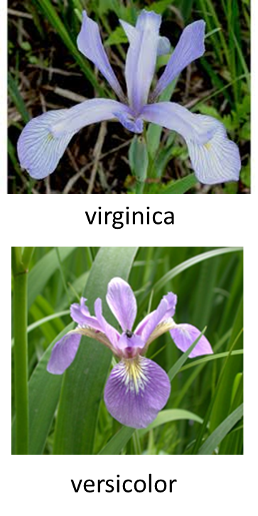

Topics: Reasoning with uncertainty, MP neuron and neural network

Answers or hints:

Poll: B

Q1:

Sequence of hypothesis testing:

Initial hypothesis: an explosion is imminent

Rule 1: LHS fails.

Rule 2: LHS not sure.

Subsidiary hypothesis: the machine has overheated

Rule 4: LHS satisfied. **Add the machine has overheated with certainty 1x0.9=0.9 to working memory.**

Subsidiary hypothesis: a valve has fractured

Rule 3: LHS satisfied. Conclude a valve has fractured with certainty 1x0.6=0.6

Rule 5: LHS satisfied. Conclude a valve has fractured with certainty 1x0.5=0.5

Combined certainty: 0.5+(1-0.5)x0.6=0.8

**Add a valve has fractured with certainty 0.8 to working memory.**

Rule 2: LHS satisfied with certainty min{0.8, 0.9}=0.8. **Add an explosion is imminent with certainty 0.8x0.7=0.56 to working memory.**

Sequence of operations:

Rule 4, Rule 3, Rule 5, and Rule 2 will fire in turn.

All the facts that will be in working memory and their certainties are as follows:

The warning light is flashing yellow, 1.0

Smoke is coming out of the vents, 1.0

The machine has overheated, 0.9

A valve has fractured, 0.8

An explosion is imminent, 0.56

Q2: Solve equations based on a truth table or use graphic interpretation.

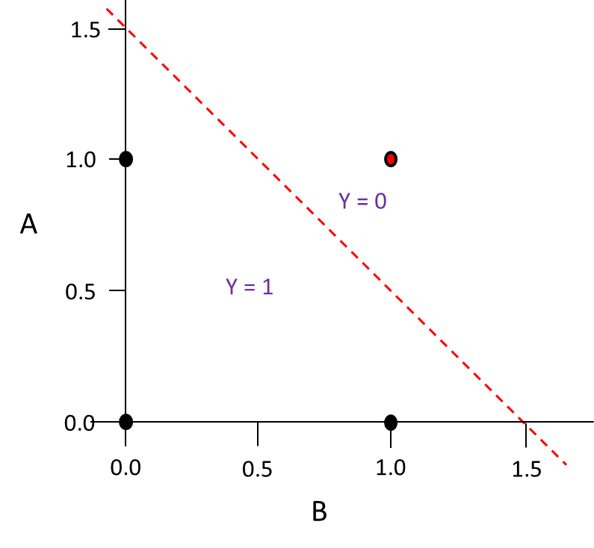NAND

θ/wA

0>θ (for A=0, B=0, Y=1)

wAA + wBB = θ

WA>θ (for A=1, B=0, Y=1)

WB>θ (for A=0, B=1, Y=1)

WA+ WB <θ (for A=1, B=1, Y=0)

A typical solution:

WA=-1, WB=-1, θ=-1.5

(The number of possible

solutions is infinite.)

θ/wB

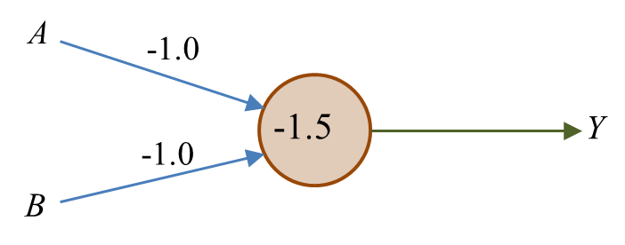

Q3: Let the MP neuron’s weights and threshold be w1, w2, and θ respectively. One possible design is to make w1x1 + w2x2 - θ = 0 represent the blue line in the following figure, which results in =5.5 (intercept on x1 axis) and θ/w2=2.5 (intercept on x2 axis). Hence, a possible design could be θ=5, w1=5/5.5=0.9, w2=5/2.5=2. The number of possible solutions is infinite. A good solution is the one with the separation line away from the samples, as far as possible.



w1x1 + w2x2 - θ = 0

θ/w1

θ/w2